Chapter 2. Experimental section

**Experimental section**

The details of the preparation and characterization of 4’-substituted 2-benzylidene-1,3-indandiones, 4’-substituted 5-benzylidenebarbituric acids and *p*-substituted (E)-1-(furan-2-yl)-3-phenylprop-2-ene-1-ones are described in this chapter.

**2.1 Preparation of 4’-substituted 2-benzylidene-1,3-indandiones.**

2-benzylidene-1,3-indandione and its substituted compounds were prepared by the reported procedure1. To the calculated amount of the appropriate benzaldehyde (12.5 mM) and 1,3-indandione (12.5 mM) in warm ethyl alcohol was added a 10% solution of sodium hydroxide (catalytic amount) and the reaction mixture stirred for 2 h to 3 h and left overnight (Scheme 2.1). The solvent was removed under vacuum. The resulting crude product was purified by column chromatography.



Scheme 2.1

**2.1.1 Characterization**

All chemicals used were purchased from Sigma Aldrich. The purity of the compounds was checked by TLC on silica gel G plates. All the compounds were characterized as 2-benzylidene-1,3-indandione and its derivatives (Fig.2.1) by UV-Visible, FT-IR and NMR spectral techniques. UV-Visible spectra were recorded on a CARY VARION (V 550), CHCl3 was used as a solvent. Infrared spectra were obtained on a PARAGON 500 spectrometer on KBr pellets. 1H and 13C spectra were obtained on a BRUKER AMX 400 MHz spectrometer. The chemical shift of 1H was measured with the peak of CDCl3 at δ 7.29 as the internal reference, while those of 13C were recorded with the central peak of CDCl3 at δ 77.03 as the internal reference.



Fig. (2.1)

Where X is the substituents viz. -OMe, -Me, -H, -Cl, -Br, and -COOH

**2.1.2 UV-visible spectral characterization**

UV-Visible absorption spectra were recorded for all the compounds and CHCl3 was used as a solvent. λmax values for various 4’-substituted 2-benzylidene-1,3-indandiones are given in Table (2.1).

**Table (2.1):** λmax values for various 4’-substituted 2-benzylidene-1,3-indandiones in CHCl3.

|  |  |  |
| --- | --- | --- |
| S.No. | Substituent X | Observed λmax  CHCl3  nm |
|  |  |  |
| 1. | -OCH3 | 525,386 |
| 2. | -CH3 | 264,357 |
| 3. | -H | 264,345 |
| 4. | -Cl | 265,351 |
| 5. | -Br | 265,353 |
| 6. | -COOH | 263,340 |
|  |  |  |

**2.1.3. FT-IR Spectra Characterization**

FT-IR spectra of *p*-substituted 2-benzylidene-3-indandiones are shown in figures

(2.8 - 2.13). FT-IR (KBr pellets) data for the above compounds are given below.

1. **2-(4’-methoxybenzylidene)-1,3-indandione:** 3439.07, 2839.62,1581.14, 1555.70, 1505.89, 1266.32, 1174.91, 1022.34, 839.46, 731.99, 526.21.
2. **2-(4’-methylbenzylidene)-1,3-indandione:** 3489.89, 1725.29,1683.93, 1588.08, 1373.46, 1351.89,1332.42, 1189.24,1080.52, 989.52,818.12,739.74.
3. **2-benzylidene-1,3-indandione:** 3783.09,3063.50,2364.96,1724.93,1683.75,1586.17,

1376.53,1345.96,1244.02,1198.94,981.07,732.69,682.38,568.09.

4. **2-(4’-chlorobenzylidene)-1,3-indandione:** 3696**.**20,3092.11,2363.08, 1726.37,

1689.99, 1609.80, 1582.35, 1486.02, 1411.93, 1203.63, 1092.42,1074.32, 830.56.

5. **2-(4’-bromobenzylidene)-1,3-indandione:** 3086.69, 1726.98, 1689.61, 1612.90,

1577.50, 1408.55, 1485.35, 1248.20,1202.37,1162.92,1072.53,828.32,736.35.

6. **2-(4’-carboxybenzylidene)-1,3-indandione:** 2825.28,2549.02, 1731.80, 1687.05,

1618.67,1592.13, 1428.79, 1293.26, 1248.65, 1202.53, 1156.73, 988.89, 734.01.

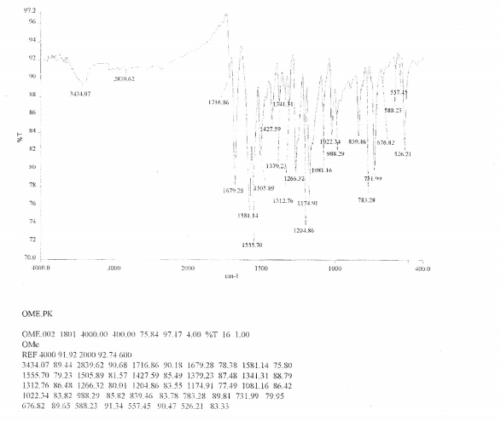

**Fig. 2.8. FT-IR spectrum of 2-(4’-methoxybenzylidene)-1,3-indandione**

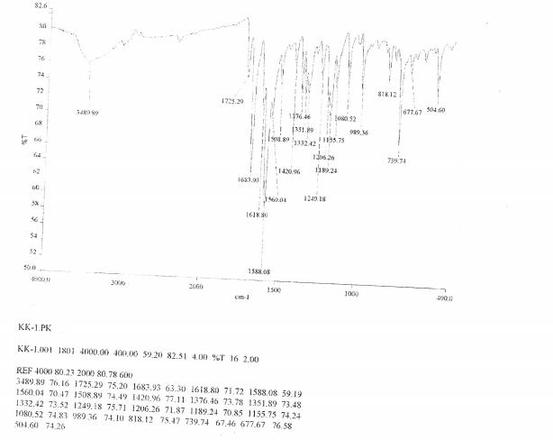

**Fig.2.9. FT-IR spectrum of 2-(4’-methylbenzylidene)-1,3-indandione**

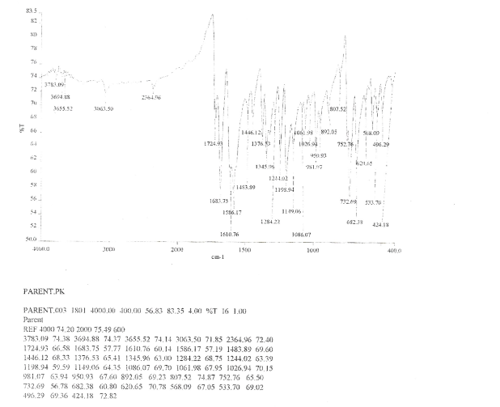

**Fig.2.10. FT-IR spectrum of 2-benzylidene-1,3-indandione**

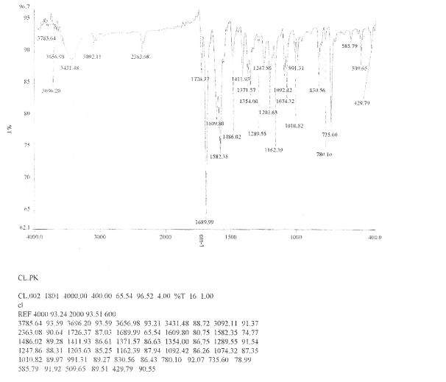

**Fig.2.11. FT-IR spectrum of 2-(4’-chlorobenzylidene)-1,3-indandione**

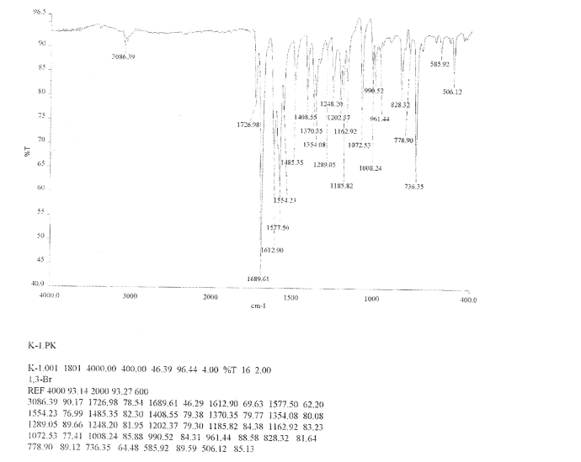

**Fig.2.12. FT-IR spectrum of 2-(4’-bromobenzylidene)-1,3-indandione**

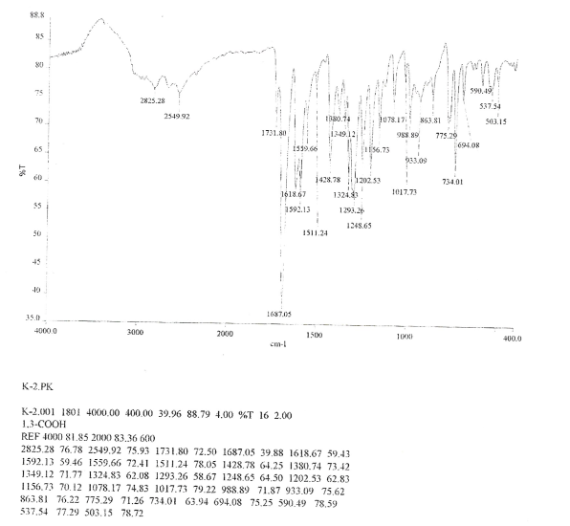

**Fig.2.13. FT-IR spectrum of 2-(4’-carboxybenzylidene)-1,3-indandione**

**Fig.2.13. FT-IR spectrum of 2-(4’-bromobenzylidene)-1,3-indandione**

**2.1.4. Assignment of 1H NMR Chemical shifts**

In 1H NMR spectra of 2-benzylidene1,3-indandione whose signals assignment were quite complicated, but the ethylene proton is well separated from the signals of the aromatic protons because of the β-proton nearest to the aromatic ring will experience a magnetic field from the induced circulation of π-electrons in the aromatic ring, which will augment the applied field and hence will lead to downfield shift.

All the aromatic protons are deshielded because of ring current effect. Assignment of the signals was based on splitting pattern and peak integration ratio. 1H NMR spectra of substituted 2-benzylidene 1,3-indandiones are given in Figs. (2.14 – 2.19). 1H NMR chemical shift data for

2-benzylidene 1,3-indandiones are given below.

1. **2-(4’-methoxybenzylidene)-1,3-indandione: δ** 3.917(s,3H), 6.998-7.027(m,2H), 7.766-7.842(m,2H), 7.842(s,1H),7.958-8.000(m,2H), 8.529-8.558(m,2H).
2. **2-(4’-methyibenzylidene)-1,3-indandione: δ** 2.343(s,3H),7.178(d,2H),

7.689-.710(m,2H), 7.766(s,1H), 7.899(dd,1H), 8.287(d,1H).

3. **2-benzylidene-1,3-indandione: δ** 7.519-7.580(m,4H), 7.824-7.846(m,2H), 7.9249(s,1H),

8.020-8.047(m,2H), 8.465-8.4869(dd,2H).

4. **2-(4’-chlorobenzylidene)-1,3-indandione: δ** 7.474-7.495(m,2H), 7.834-7.848(m,2H),

7.827(s,1H), 7.997-8.018(m,2H), 8.417-8.438(m,2H).

5. **2-(4’-bromobenzylidene)-1,3-indandione: δ** 7.640-7.662(dd,2H), 8.322-8.353(dd,2H),

7.811(s,1H), 8.011-8.035(m,2H), 7.829-7.851(m,2H).

6. **2-(4’-carboxybenzylidene)-1,3-indandione: δ** 7.851(s,1H), 7.902-7.923(m,2H), 7.955-

7.992(m,2H), 8.039(d,2H), 8.465(d,2H).

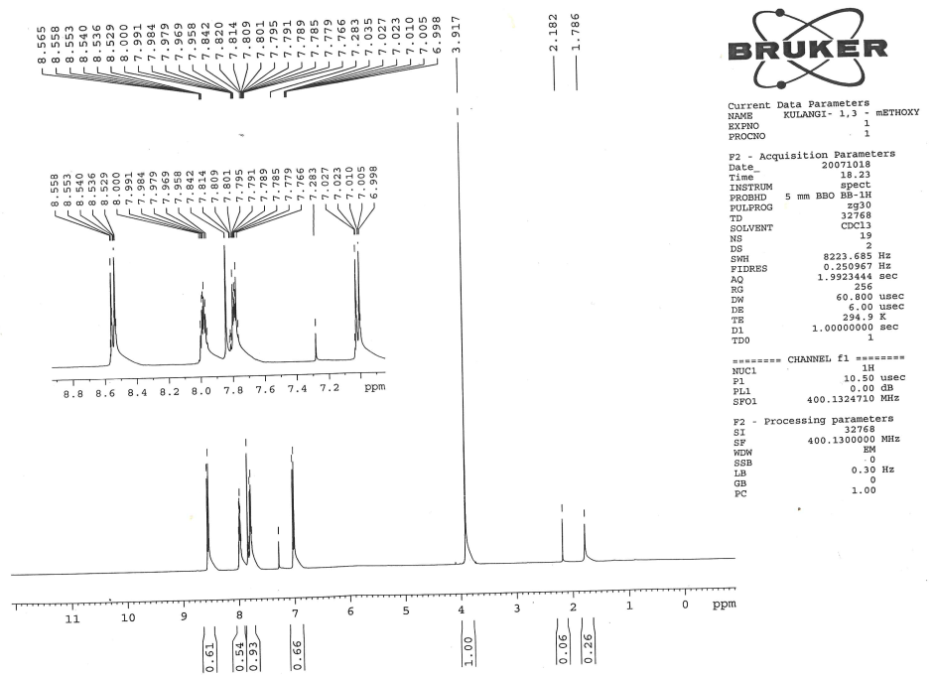

**Fig. 2.14. 1H NMR spectrum of** **2-(4’-methtoxybenzylidene)-1,3-indandione**

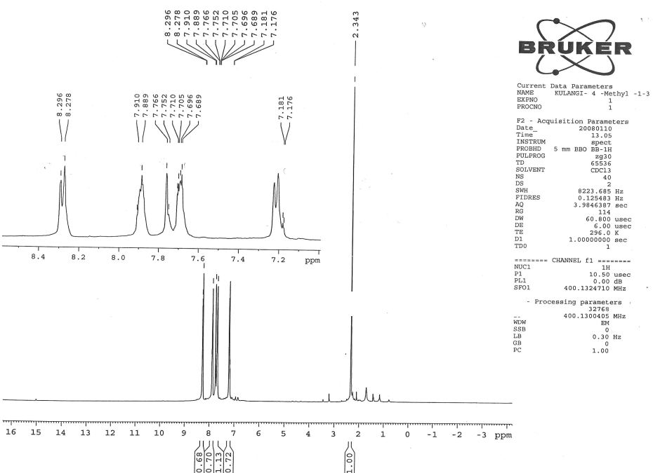

**Fig.2.15**. **1H NMR spectrum of** **2-(4’-methylbenzylidene)-1,3-indandione**

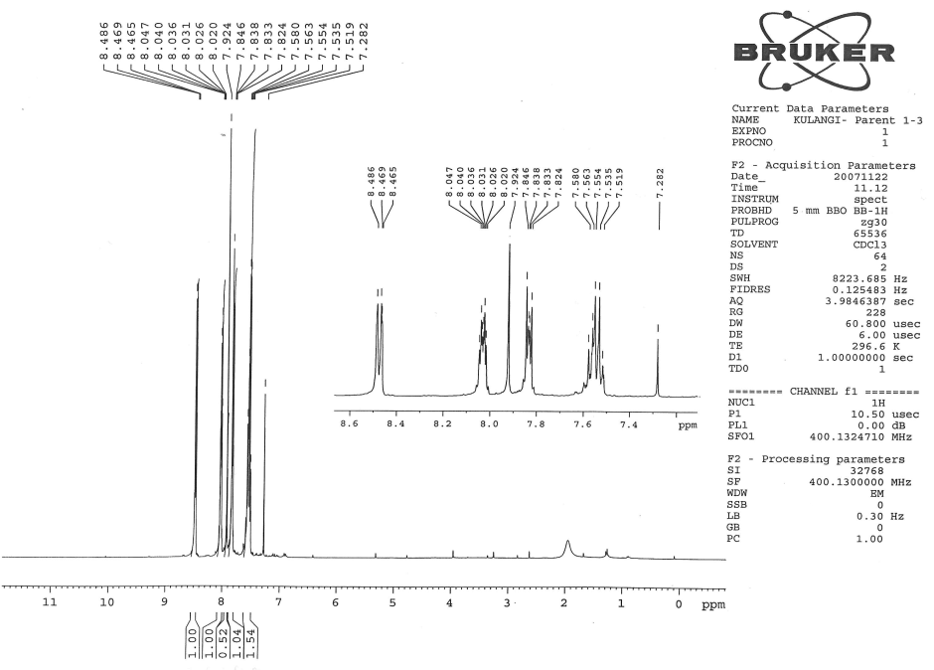

**Fig.2.16** **1H NMR spectrum of** **2-benzylidene-1,3-indandione**

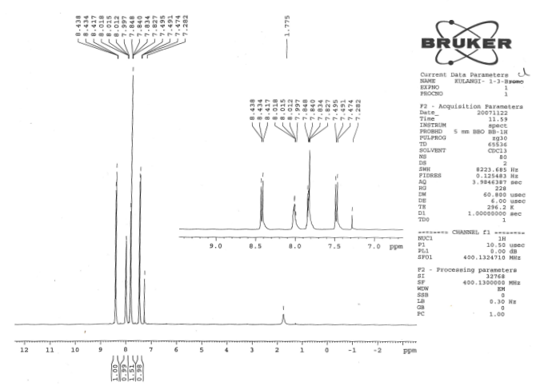

**Fig.2.16** **1H NMR spectrum of** **2-benzylidene-1,3-indandione**

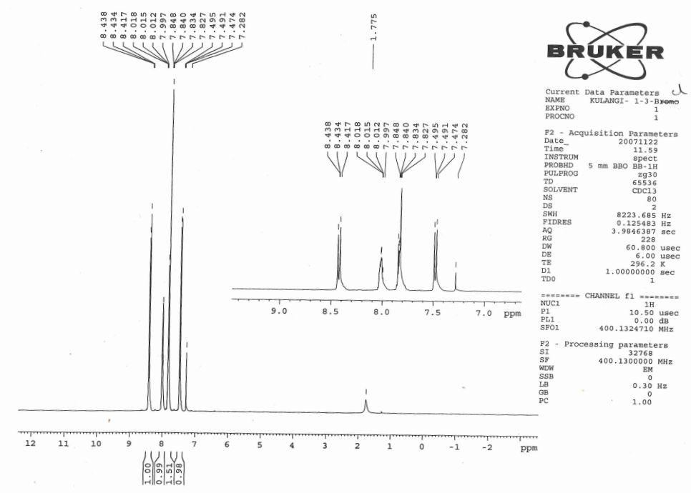

**Fig.2.17**  **1H NMR spectrum of** **2-(4’-chlorobenzylidene)-1,3-indandione**

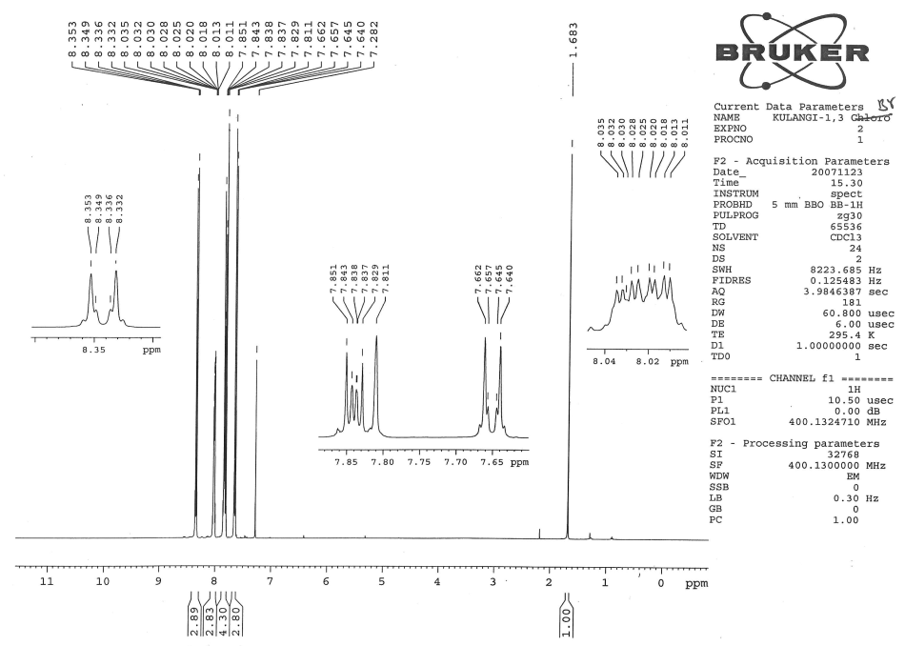

**Fig.2.18**  **1H NMR spectrum of** **2-(4’-bromobenzylidene)-1,3-indandione**

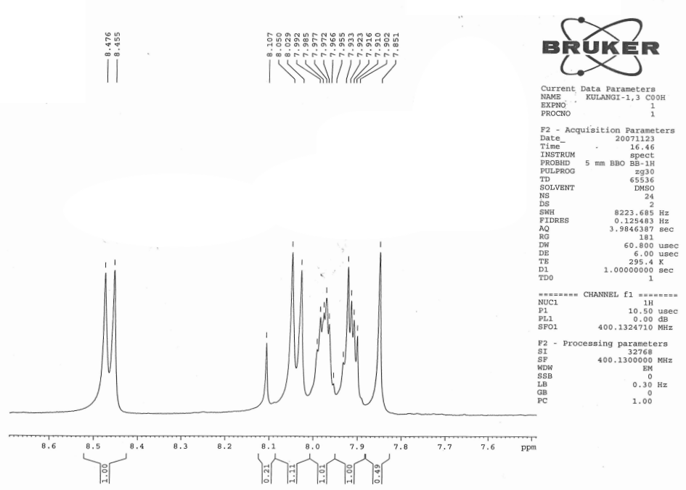

**Fig.2.19**  **1H NMR spectrum of** **2-(4’-carboxybenzylidene)-1,3-indandione**

**2.1.5. Assignment of 13C NMR signals**

13C NMR signals were assigned for various carbons were based on the

1. Chemical shift exhibited by the signals.
2. Relative signal intensity.

13C chemical shifts were assigned by intensity and SCS consideration. 13C NMR spectra of substituted 2-benzylidene 1,3-indandiones are given in figures (2.20-2.25). the proton-noise decoupled spectrum of parent compound contains 14 signals corresponding to 14 different carbon atoms. In all the spectra, the two carbonyl carbon signals were readily recognized from their low intensity and also well separated from other signals to downfield extreme, since their assignment was not difficult.

One upfield signal was assigned to C7’ carbon atom at 135.45 ppm. The intensity was somewhat larger. The C6 carbon gives a peak at 135.25 ppm. The 13C chemical shifts of p-substituted 2-benzylidene 1.3-indandiones are given in Table (2.2).

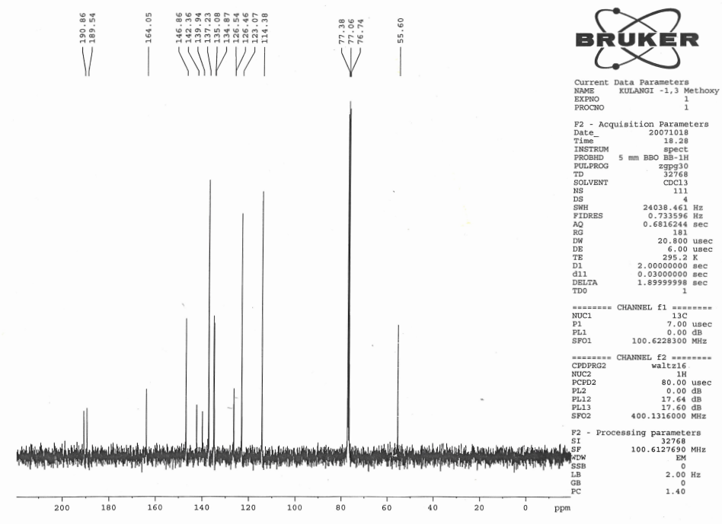

**Fig.2.20** **13C NMR spectrum of** **2-(4’-methtoxybenzylidene)-1,3-indandione**

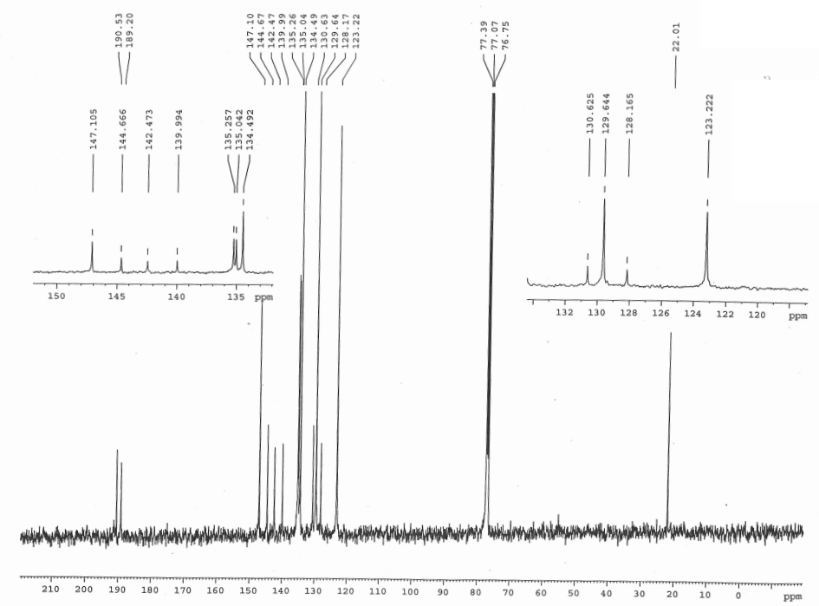

**Fig.2.21** **13C NMR spectrum of** **2-(4’-methylbenzylidene)-1,3-indandione**

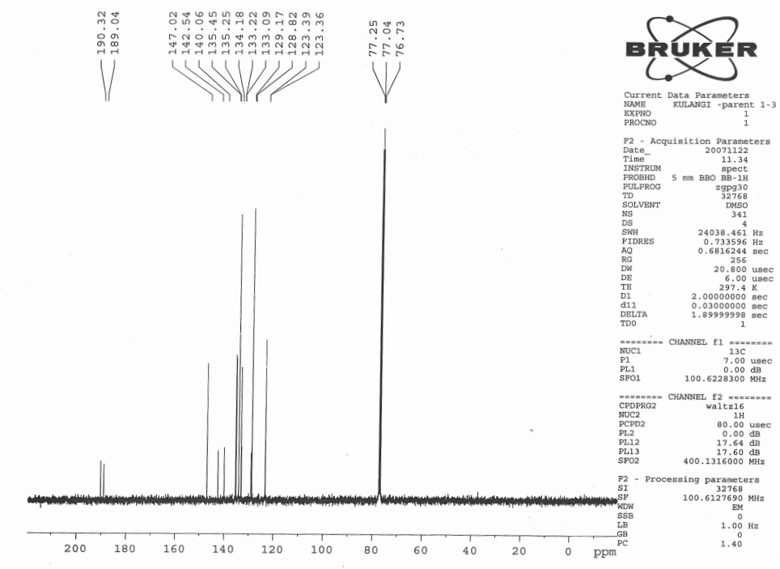

**Fig.2.22**  **13C NMR spectrum of** **2-benzylidene-1,3-indandione**



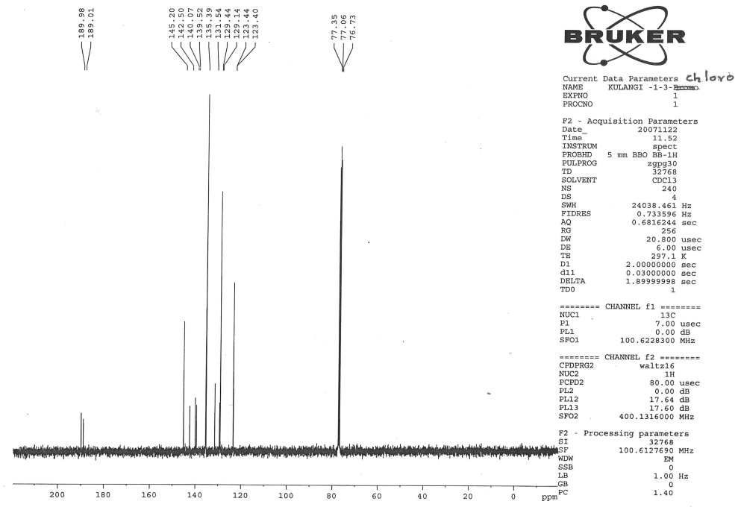

**Fig.2.23**  **13C NMR spectrum of** **2-(4’-chlorobenzylidene)-1,3-indandione**

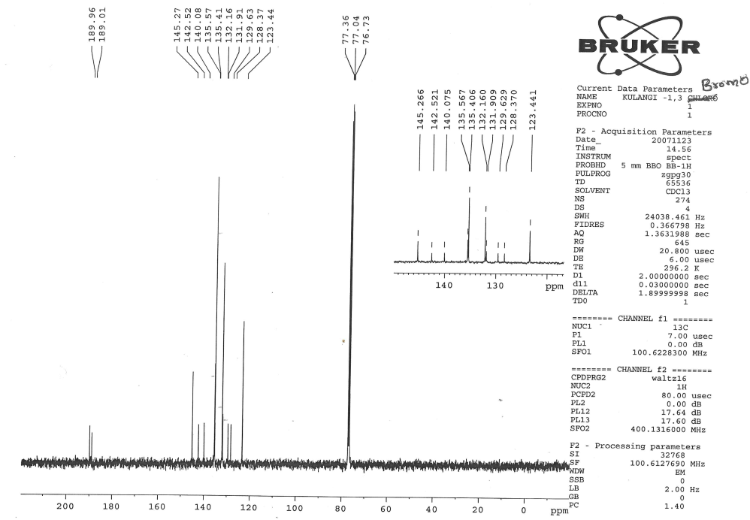

**Fig.2.24**  **13C NMR spectrum of** **2-(4’-bromobenzylidene)-1,3-indandione**

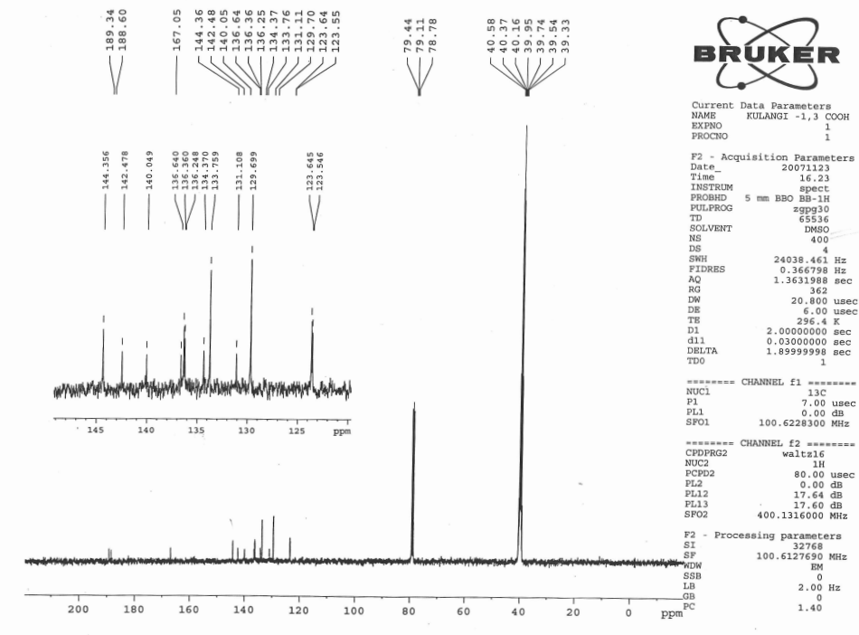

**Fig.2.25**  **13C NMR spectrum of** **2-(4’-carboxybenzylidene)-1,3-indandione**

**Table (2.2): 13C NMR Chemical shifts of *p*- substituted 2-benzylidene -1,3-indandiones**

|  |  |  |  |  |  |  |  |  |  |
| --- | --- | --- | --- | --- | --- | --- | --- | --- | --- |
| S.No. | Substituent X | C1 | C3 | C6 | C7 | C1’ | C3’,5’ | C7 | C in  substituent |
| 1. | *p*-OCH3 | 190.86 | 189.54 | 134.87 | 123.07 | 126.46 | 114.38 | 146.86 | 55.60 |
| 2. | *p*-CH3 | 190.53 | 189.20 | 135.04 | 123.22 | 128.17 | 123.22 | 147.10 | 22.01 |
| 3. | H | 190.32 | 189.04 | 135.25 | 123.26 | 129.17 | 128.82 | 135.45 | - |
| 4. | *p*-Cl | 189.98 | 189.01 | 135.39 | 123.44 | 131.54 | 129.14 | 145.20 | - |
| 5. | *p*-Br | 189.96 | 189.01 | 135.57 | 123.44 | 129.63 | 132.16 | 145.27 | - |
| 6. | *p*-COOH | 189.34 | 188.60 | 136.36 | 123.64 | 134.37 | 129.70 | 144.36 | 39.05 |

**2.2 Preparation of *p*-substituted 5-benzylidenebarbituric acids.**

5-benzylidenebarbituric acid and its substituted compounds were prepared by the modified procedure2.

To the calculated amount of the pure benzaldehyde (2 g, 0.015 mol) and barbituric acid (1.55g, 0.015 mol) in warm ethyl alcohol was added a 10% solution of sodium hydroxide (catalytic amount) and the reaction mixture stirred for 2 hours. After completion of the reaction as indicated by TLC, the reaction mixture was left overnight (scheme 2.2). The solvent was removed in vacuum. The resulting crude product was purified by column chromatography.



**(Scheme 2.2)**

**2.2.1 Characterization**

All the compounds were characterized as 5-benzylidenebarbituric acid and its derivatives (Fig.2.26) by 1H and 13C NMR spectral techniques. 1H and 13C spectra were obtained on a BRUKER AMX 400 MHz spectrometer. Chemical shifts of 1H were measured with the peak of DMSO at δ 2.51 as the internal reference, while those of 13C were recorded with the central peak of DMSO at δ 39.90 as the internal reference.



Fig. (2.26)

**2.2.2 Assignment of 1H NMR Signals**

In 1H NMR spectrum of 5-benzylidenebarbituric acid whose, signals assignment was not difficult and all signals well separated from each other. The NH-proton of N8 and N10 atoms are expected to downfield than the -CH-proton of C5 carbon atom. The -CH-proton of C5 is well separated from all other protons signals, hence it’s assignment is not difficult. 1H NMR spectra of substituted 5-benzylidenebarbituric acids are given in Fig’s (2.27 – 2.33).

**1H NMR Spectral data of substituted 5-benzylidenebarbituric acids are given below.**

1. 5-(4’-Methoxybenzylidene)barbituric acid

**δ 3.877 (s,3H), 7.065 (d,2H), 8.252(s,1H), 8.369 (d,2H), 11.175 (s,1H), 11.302 (s,1H).**

2. 5-(4’-Hydroxybenzylidene)barbituric acid

**δ 6.878 (d,2H), 8.213 (s,1H), 8.320 (d,2H), 10.851 (s,1H), 11.117(s,1H), 11.249 (s,1H).**

3. 5-(4’-Methylbenzylidene)barbituric acid

**δ 2.385 (s,3H), 7.304 (d,2H), 8.094 (d,2H), 8.255 (s,1H), 11.218 (s,1H), 11.365 (s,1H).**

4. 5-Benzylidenebarbituric acid

**δ 7.485 (m,3H), 8.073 (d,2H), 8.285 (s,1H), 11.238 (s,1H), 11.397 (s,1H).**

5. 5-(4’-Chlorobenzylidene)barbituric acid

**δ 7.518 (d,2H), 8.069 (d,2H), 8.243 (s,1H), 11.275 (s,1H), 11.425 (s,1H).**

6. 5-(4’-Bromobenzylidene)barbituric acid

**δ 7.670 (d,2H), 7.979 (d,2H), 8.223 (s,1H), 11.272 (s,1H), 11.421 (s,1H).**

7. 5-(4’-Nitrobenzylidene)barbituric acid

**δ 8.017 (d,2H), 8.245 (d,2H), 8.324 (s,1H), 11.329 (s,1H), 1.504 (s,1H).**

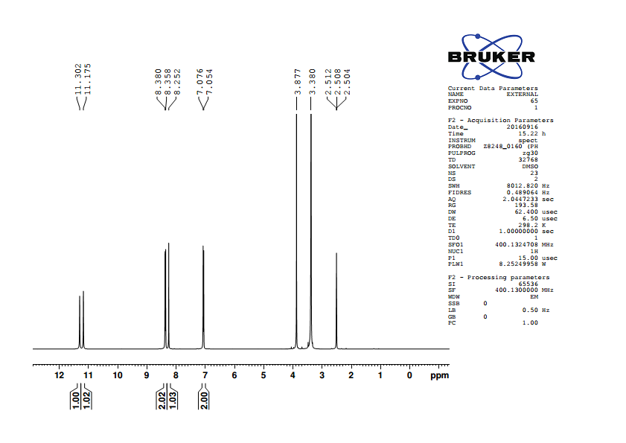

**Fig.2.27 1H NMR spectrum of** **5-(4’-methoxybenzylidene)barbituric acid**

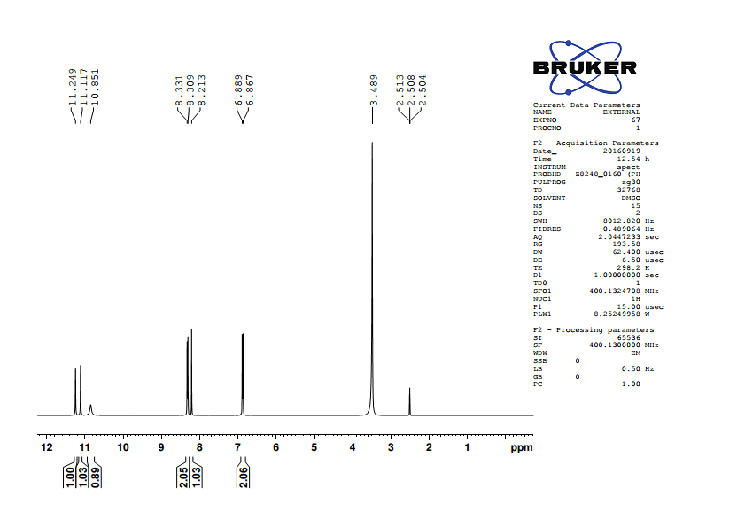

**Fig.2.28 1H NMR spectrum of** **5-(4’-hydroxybenzylidene)barbituric acid**

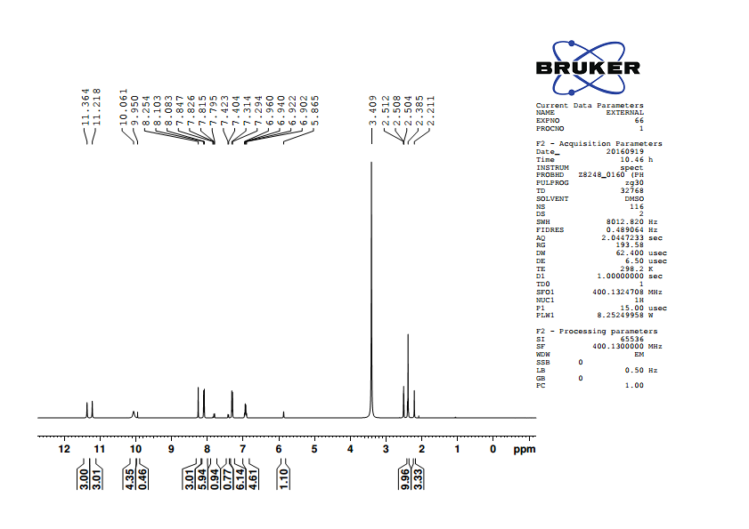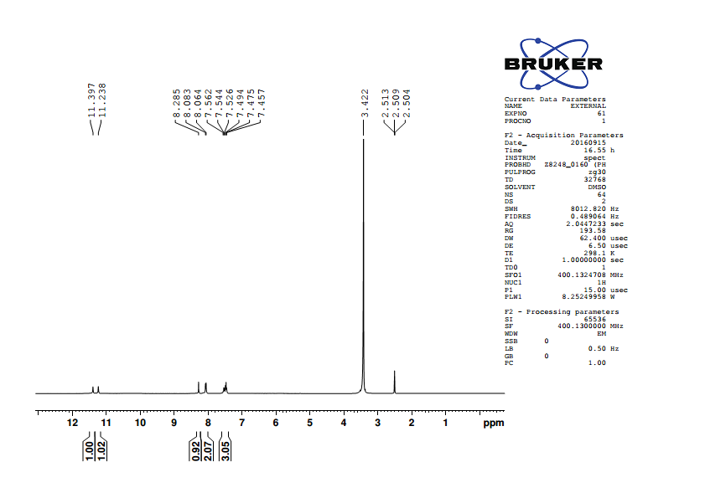

**Fig.2.29 1H NMR spectrum of** **5-(4’-methylbenzylidene)barbituric acid**

**Fig.2.30 1H NMR spectrum of** **5-benzylidenebarbituric acid**

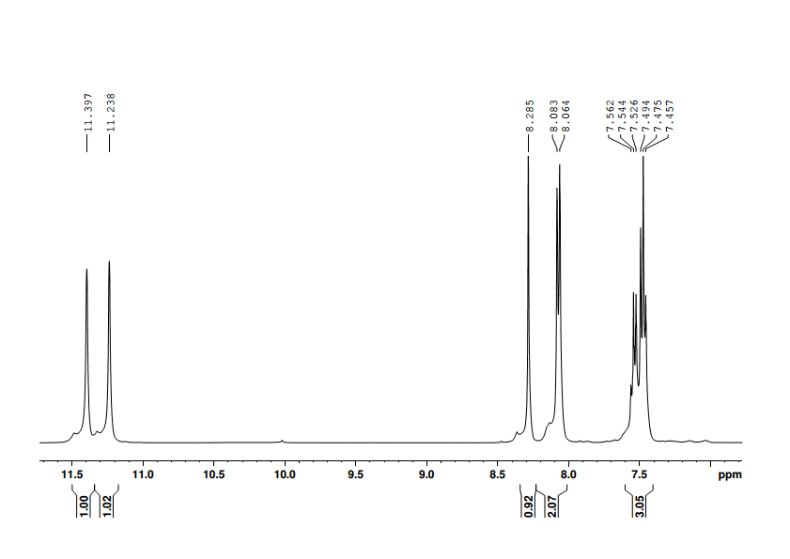

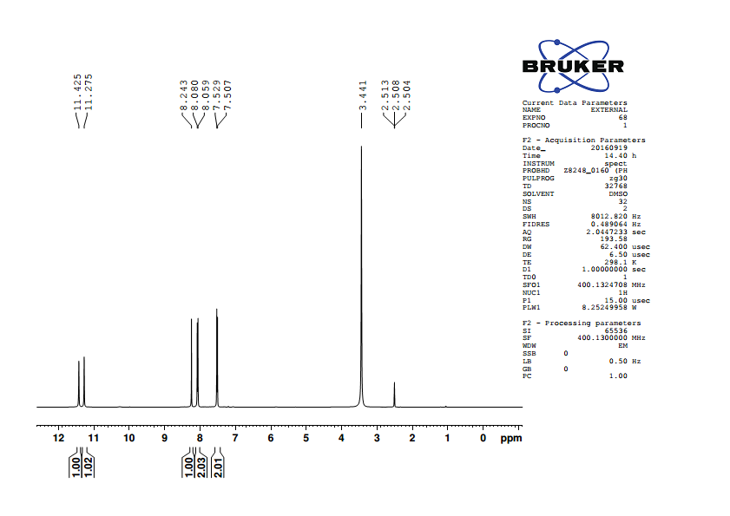

**Fig.2.31 1H NMR spectrum of** **5-(4’-chlorobenzylidene)barbituric acid**

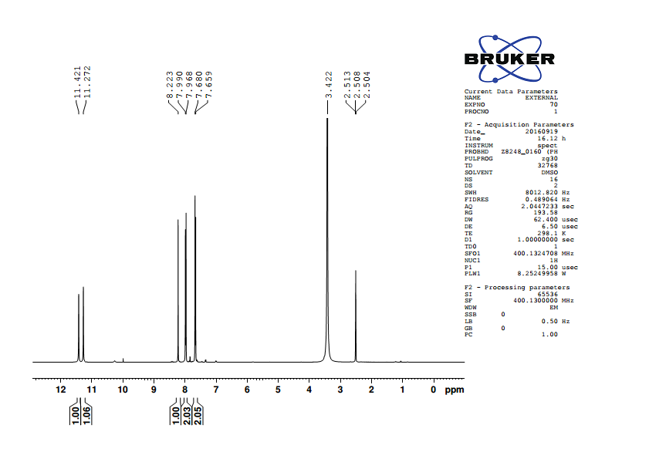

**Fig.2.32 1H NMR spectrum of** **5-(4’-bromobenzylidene)barbituric acid**

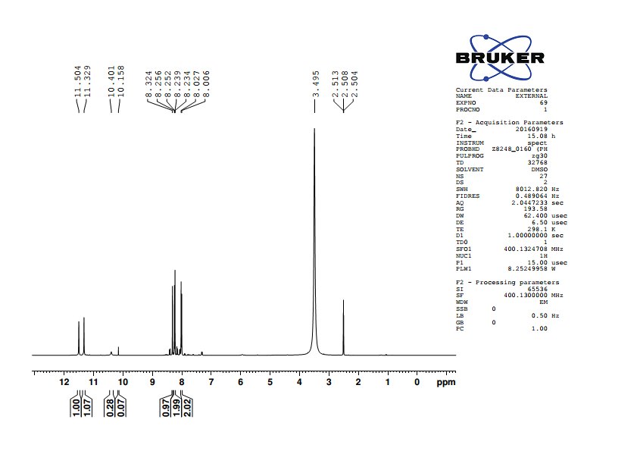

**Fig.2.33 1H NMR spectrum of** **5-(4’-nitroobenzylidene)barbituric acid**

**Table (2.3): 1H NMR chemical shifts of** **substituted 5-benzylidenebarbituric**

**acids**

|  |  |  |  |  |  |  |  |
| --- | --- | --- | --- | --- | --- | --- | --- |
|  |  |  |  |  |  |  |  |
| S.No. | Substituent, -X |  | H22’ | H33’ | H5 | H8 | H10 |
|  |  |  |  |  |  |  |  |
| 1. | -OCH3 |  | 7.065 | 8.369 | 8.252 | 11.175 | 11.302 |
|  |  |  |  |  |  |  |  |
| 2. | -OH |  | 6.878 | 8.32 | 8.213 | 11.117 | 11.249 |
|  |  |  |  |  |  |  |  |
| 3. | -CH3 |  | 7.304 | 8.094 | 8.255 | 11.218 | 11.365 |
|  |  |  |  |  |  |  |  |
| 4. | -H |  | 7.485 | 8.073 | 8.285 | 11.238 | 11.397 |
|  |  |  |  |  |  |  |  |
| 5. | -Cl |  | 7.518 | 8.069 | 8.243 | 11.275 | 11.425 |
|  |  |  |  |  |  |  |  |
| 6. | -Br |  | 7.670 | 7.979 | 8.223 | 11.272 | 11.421 |
|  |  |  |  |  |  |  |  |
| 7. | -NO2 |  | 8.245 | 8.017 | 8.324 | 11.329 | 11.504 |

**2.2.3 Assignment of 13C NMR signals**

13C NMR signals were assigned for various carbons were based on the

1. Chemical shift exhibited by the signals
2. Relative signal intensity
3. Empirical additivity rules

13C NMR spectrum of 5-benzylidenebarbituric acid contains 9 signals corresponding to 9 different carbon atoms. In all the spectra, carbonyl carbon signal was readily recognized and also well separated from other signals to downfield extreme, since its assignment was not difficult. 13C NMR spectra of substituted

5-benzylidenebarbituric acids are given in fig’s (2.34 - 2.40).

**13C NMR Spectra of 5-benzylidenebarbituric acids**

1*.* 5-(4’-Methoxybenzylidene)barbituric acid

**δ 56.22, 114.41, 116.00, 125.62, 137.96, 150.67, 155.46, 162.64, 163.92, 164.39.**

2. 5-(4’-Hydroxybenzylidene)barbituric acid

**δ 114.61, 115.97, 124.24, 138.77, 150.70, 156.05, 162.75,163.48, 164.59.**

3. 5-(4’-Methylbenzylidene)barbituric acid

**δ 118.30, 129.33, 130.31, 134.43, 143.96, 150.68, 155.46, 162.26, 164.08.**

4. 5-Benzylidenebarbituric acid

**δ 119.55, 128.52, 132.69, 133.11, 133.54, 150.69, 155.20, 162.03, 163.87**.

5. 5-(4’-Chlorobenzylidene)barbituric acid

**δ 120.09, 128.55, 132.01, 135.15, 137.21, 150.65, 153.52, 162.04, 163.67.**

6. 5-(4’-Bromobenzylidene)barbituric acid

**δ 120.24, 126.29, 131.51, 132.40, 135.15, 150.65, 153.56, 162.04, 163.67.**

7. 5-(4’-Nitrobenzylidene)barbituric acid

**δ 123.15, 123.37, 132.69, 140.48, 148.49, 150.68, 151.63, 161.62, 163.13.**

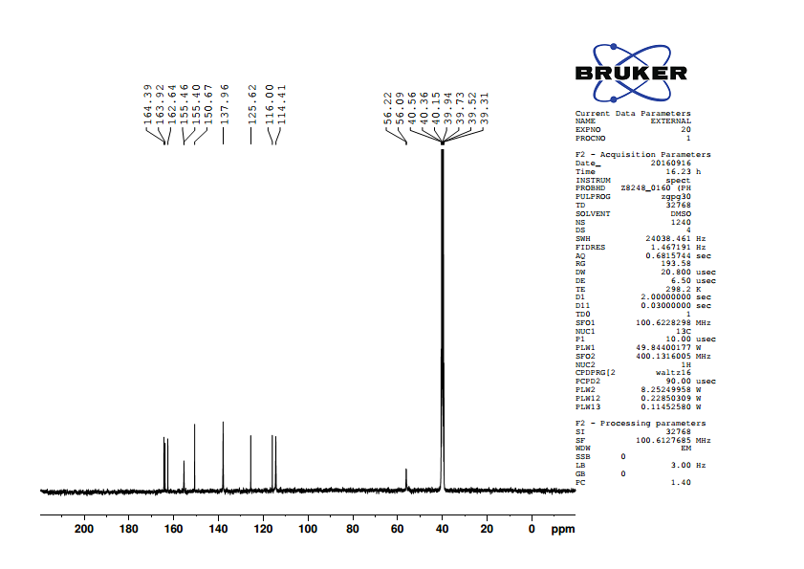

**Fig.2.34 13C NMR spectrum of** **5-(4’-methoxybenzylidene)barbituric acid**

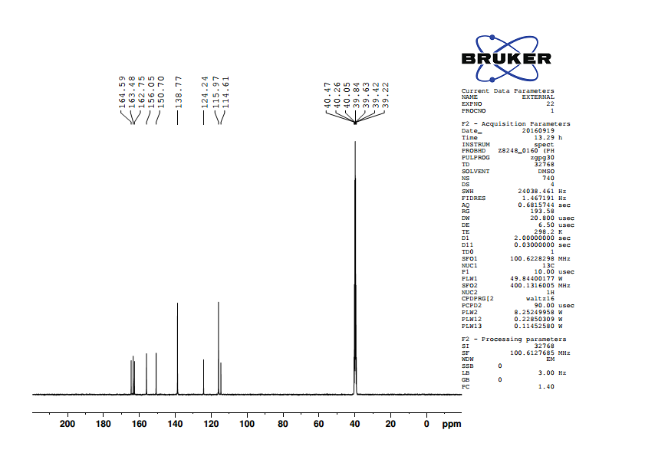

**Fig.2.35 13C NMR spectrum of** **5-(4’-hydroxybenzylidene)barbituric acid**

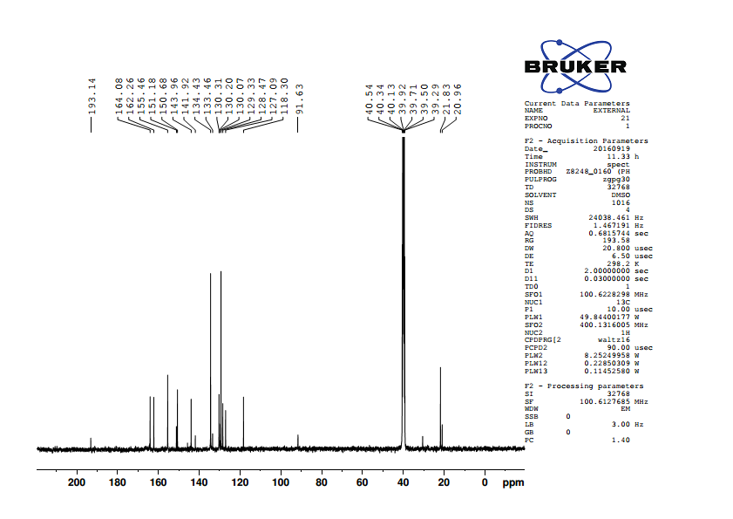

**Fig. 2.36 13C NMR spectrum of** **5-(4’-methylbenzylidene)barbituric acid**

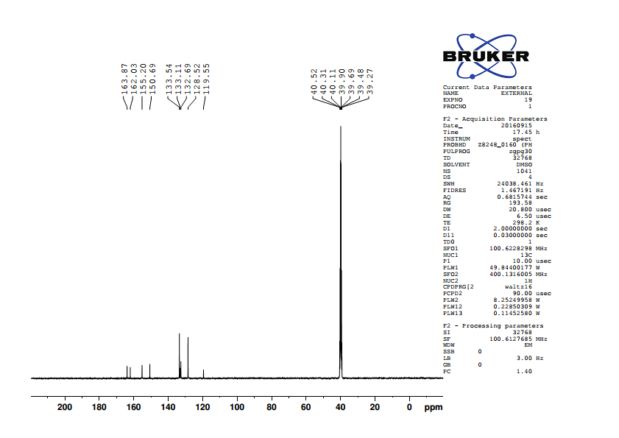

**Fig.2.37 13C NMR spectrum of** **5-benzylidenebarbituric acid**

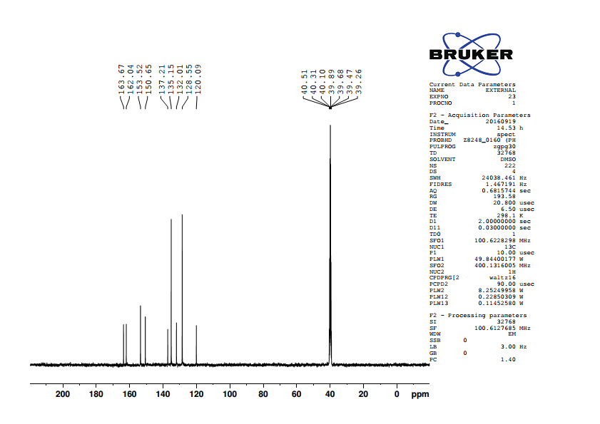

**Fig. 2.38 13C NMR spectrum of** **5-(4’-chlorobenzylidene)barbituric acid**

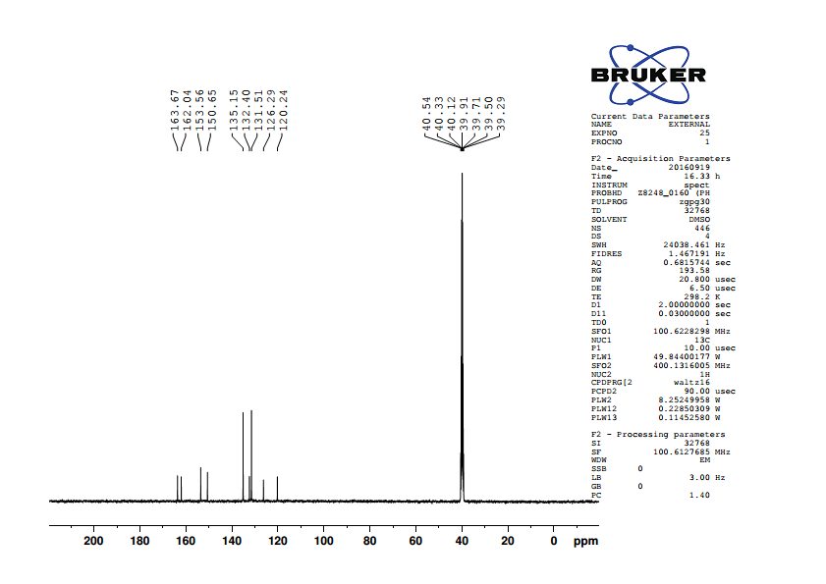

**Fig. 2.39 13C NMR spectrum of** **5-(4’-bromobenzylidene)barbituric acid**

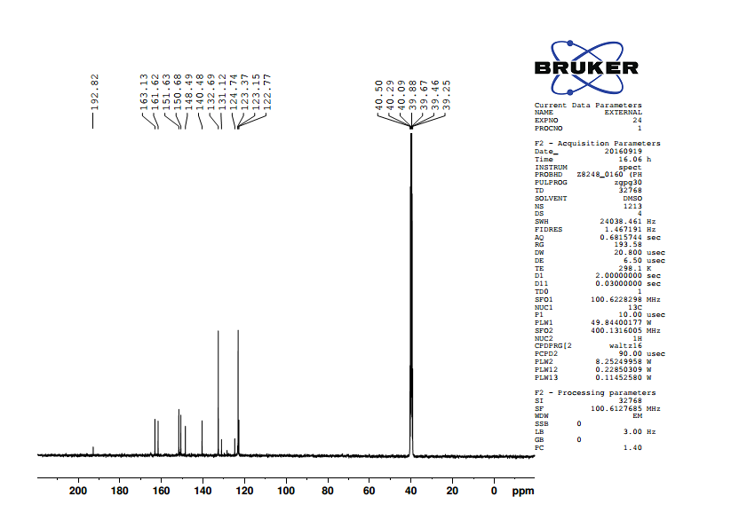

**Fig.2.40 13C NMR spectrum of** **5-(4’-nitrobenzylidene)barbituric acid**

**Table (2.4): 13C NMR chemical shifts of substituted 5-benzylidenebarbituric acids**

|  |  |  |  |  |  |  |  |  |  |  |
| --- | --- | --- | --- | --- | --- | --- | --- | --- | --- | --- |
| **S.No.** | *p*-X | **C1** | **C22’** | **C33’** | **C4** | **C5** | **C6** | **C7** | **C9** | **C11** |
|  |  |  |  |  |  |  |  |  |  |  |
| 1 | -OCH3 | 162.64 | 114.41 | 137.96 | 125.62 | 155.46 | 116 | 163.92 | 150.67 | 164.39 |
|  |  |  |  |  |  |  |  |  |  |  |
| 2 | -OH | 163.48 | 115.97 | 138.77 | 124.24 | 156.05 | 114.61 | 162.75 | 150.7 | 164.59 |
|  |  |  |  |  |  |  |  |  |  |  |
| 3 | -CH3 | 143.96 | 129.33 | 134.43 | 130.31 | 155.46 | 118.3 | 162.26 | 150.68 | 164.08 |
|  |  |  |  |  |  |  |  |  |  |  |
| 4 | -H | 133.11 | 128.52 | 133.54 | 132.69 | 155.2 | 119.55 | 162.03 | 150.69 | 163.87 |
|  |  |  |  |  |  |  |  |  |  |  |
| 5 | -Cl | 137.21 | 128.55 | 135.15 | 132.01 | 153.52 | 120.09 | 162.04 | 150.65 | 163.67 |
|  |  |  |  |  |  |  |  |  |  |  |
| 6 | -Br | 126.29 | 131.51 | 135.15 | 132.4 | 153.56 | 120.24 | 162.04 | 150.65 | 163.67 |
|  |  |  |  |  |  |  |  |  |  |  |
| 7 | -NO2 | 148.49 | 132.69 | 123.37 | 140.48 | 151.63 | 123.15 | 161.62 | 150.68 | 163.13 |

**2.3 Preparation of substituted (E)-1-(furan-2-yl)-3-phenylprop-2-ene-1-one**.

(E)-1-(furan-2-yl)-3-phenylprop-2-ene-1-one and its *p*-substituted compounds were prepared by the following procedure3.

The mixture of the calculated amount of the pure 2-acetylfuran (0.55g ~ 0.005 moles) in cold ethanol and 10% solution of sodium hydroxide (catalytic amount) was cooled in a water bath to 0o C. To this mixture pure benzaldehyde (0.583 g ~ 0.0055 moles) in cold ethanol was added drop by drop for 30 minutes. The reaction mixture stirred for 2 hours. Then it was kept in the refrigerator for overnight. The precipitated solid was collected and recrystallized using ethanol-chloroform (10:1) mixture.



**Scheme (2.3)**

All the substituted compounds were prepared by using the above procedure.

**2.3.1 Characterization**

All the compounds were characterized as (E)-1-(furan-2-yl)-3-phenylprop-2-ene-1-one and its derivatives by 1H and 13C NMR spectral techniques. All 1H and 13C NMR spectra were obtained on a BRUKER AV 400 MHz spectrometer. Chemical shifts of 1H were measured with the central peak of CDCl3 at δ 7.259 as the internal reference, while those of 13C were measured with the central peak of CDCl3 at δ 77.54 as the internal reference.



**Fig. (2.41)**

where X is the substituents viz. *p*-NMe2, *p*-Me, H, *p*-Cl, *p*-F, *p*-CHO.

**2.3.2 Assignment of 1H NMR spectra**

In 1H NMR spectra of (E)-1-(furan-2-yl)-3-phenylprop-2-ene-1-ones whose signals assignment were not difficult and all signals well separated from each other. The -CH- proton of C11 carbon atom is expected to downfield than -CH- proton of C9 carbon atom. The -CH- proton of C10 is well separated from all other protons signals, hence it’s assignment is not difficult. Two ethylenic protons C6 and C5 carbon atoms are well separated from each other. The α-ethylenic proton is expected to be downfield shift since it is proximity to the carbonyl group. Assignment of the signals was based on splitting pattern and peak integration ratio. 1H NMR spectra of (E)-1-(furan-2-yl)-3-phenylprop-2-ene-1-ones are given in Fig’s (2.42 -2.46).

**1H NMR spectra of (E)-1-(furan-2-yl)-3-phenylprop-2-ene-1-ones are given below.**

1. **(E)-1-(furan-2-yl)-3-(4’ -N,N dimethylaminophenyl)prop-2-ene-1-one:**

**δ** 3.043(s,6H), 6.562 (d,d,1H), 6.690 (d,2H), 7.256 (d,1H), 7.262 (d,1H),7.554

(d,2H), 7.616 (m,1H), 7.856 (d,1H).

1. **(E)-1-(furan-2-yl)-3-(4’ -methylphenyl)prop-2-ene-1-one:**

**δ** 7.233(d,d, 1H), 7.330(d,1H), 7.561(d,2H), 7.421(d,1H), 7.233(d,1H), 7.233(d,2H),

7.656(m,1H),7.872(d,1H), 2.401(T,3H).

1. **(E)-1-(furan-2-yl)-3-phenylprop-2-ene-1-one:**

**δ** 6.600 (d,d,1H), 7.336 (d,1H), 7.421(m.2H), 7.423 (d,1H), 7.456(d,1H), 7.655(m,2H),

**7.**657(m,1H), 7.885(d,1H).

1. **(E)-1-(furan-2-yl)-3-(4’-chlorophenyl)prop-2-ene-1-one:**

**δ** 6.606(d,d,1H), 7.339(d,1H), 7.394(d,2H), 7.425(d,1H), 7.584(d,1H), 7.584(d,2H),

7.658(m,1H), 7.822(d,1H).

1. **(E)-1-(furan-2-yl)-3-(4’ -fluorophenyl)prop-2-ene-1-one:**

**δ** 6.599 (d,d,1H), 7.107(m,2H), 7.329(d,1H), 7.380(d,1H), 7.642(m,2H), 7.650(m,1H), 7.837(d,1H).

1. **(E)-1-(furan-2-yl)-3-(4’ -oxophenyl)prop-2-ene-1-one:**

**δ** 6.633(d,d 1H), 7.384(d,1H), 7.807(d,2H), 7.566(d,1H), 6.633(d,1H), 7.939(d,2H),

7.690(m,1H), 7.895(d,1H), 10.056(s,1H).

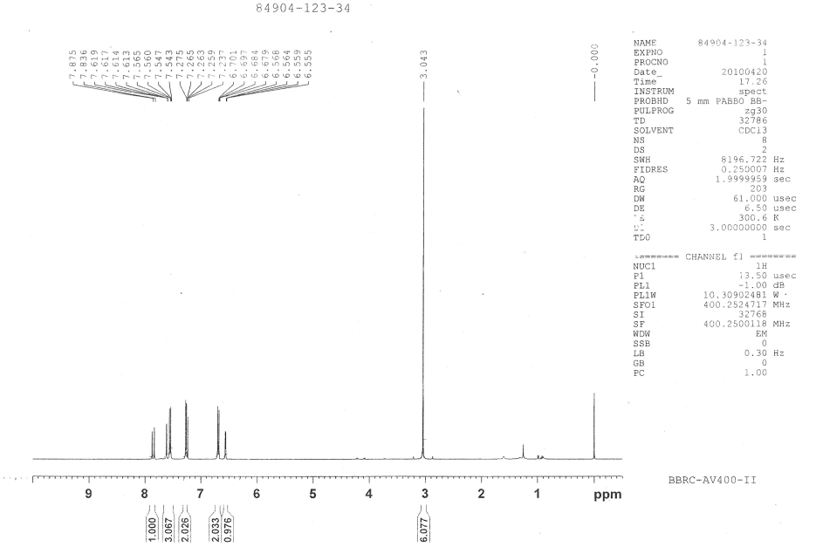

**Fig.2.42. 1H NMR spectra of (E)-1-(furan-2-yl)-3-(4’ -N,N dimethylaminophenyl)prop-2-ene-1-one**

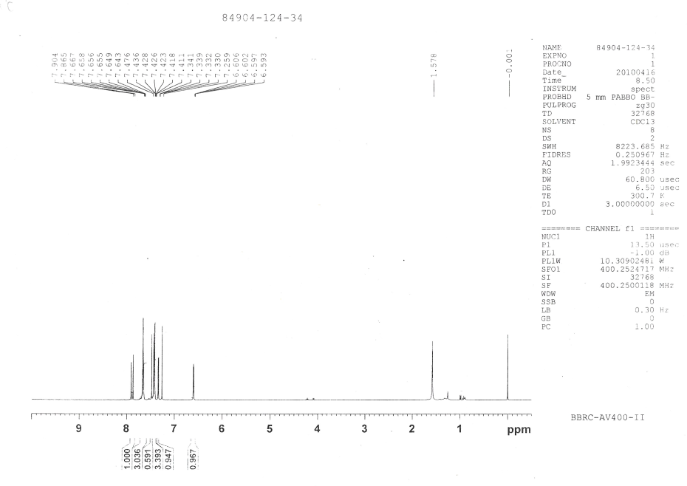

**Fig**.**2.43** **1H NMR spectra of (E)-1-(furan-2-yl)-3-phenylprop-2-ene-1-one**

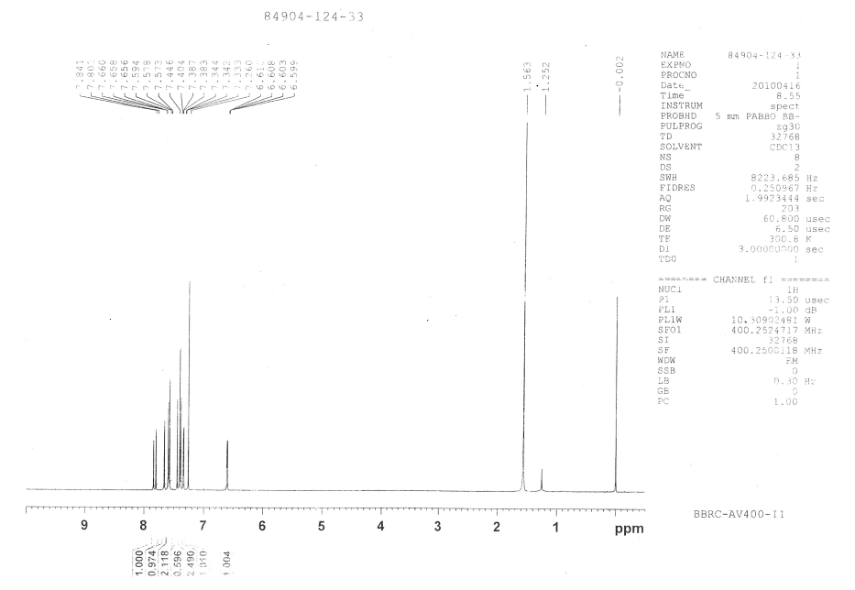

**Fig.2.44** **1H NMR spectra of (E)-1-(furan-2-yl)-3-(4’-chlorophenyl)prop-2-ene-1-one**

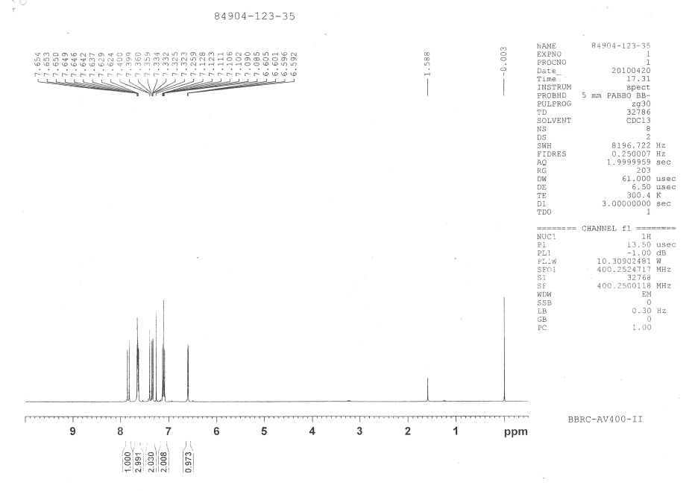

**Fig .2.45** **1H NMR spectra of**  **(E)-1-(furan-2-yl)-3-(4’ -fluorophenyl)prop-2-ene-1-one**

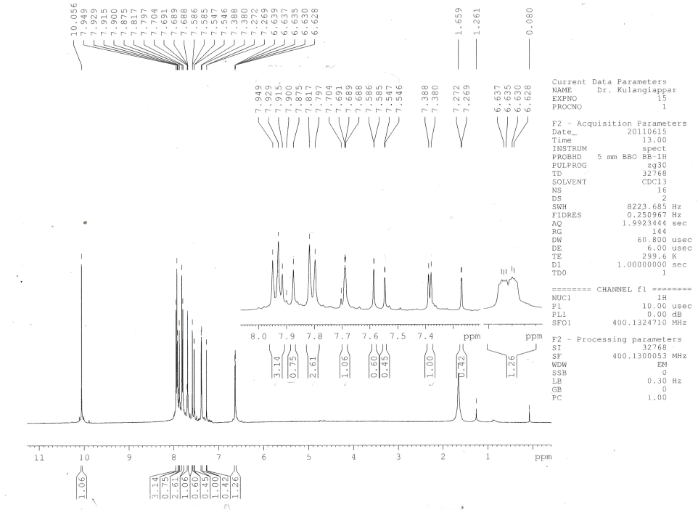

**Fig.2.46**  **1H NMR spectra of (E)-1-(furan-2-yl)-3-(4’ -oxophenyl)prop-2-ene-1-one**

**2.3.3 Assignment of 13C NMR signals**

13C NMR signals were assigned for various carbons were based on the

1. Chemical shift exhibited by the signals
2. Relative signal intensity,
3. Empirical additivity rules.

The proton noise decoupled spectrum of parent compound contains 11 signals corresponding to 11 different carbon atoms. In all the spectra, carbonyl carbon signal was readily recognized from its low intensity and also well separated from other signals to the downfield extreme, since its assignment was not difficult.

Two more low-intensity peaks were readily assigned for C8 and C4 carbon atoms. Due to nearby oxygen atoms in the ring the downfield signal at 153.73 ppm was assigned for C8 carbon atom. The upfield signal at 134.75 ppm was assigned for C4 carbon atom.

There are remaining eight signals for eight carbon atoms in which, six signals appeared almost same intensity other two signals appeared twice in intensity. This is due to the number of protons attached to the sp2 carbon atoms. The two high-intensity signals were readily assigned for aromatic carbon C3,3’ and C2,2’ atoms. This is due to the styrene as substituent since the upfield signal is 128.54 ppm was assigned for (*ortho*) C2,2’ carbon atom and next downfield signal at 128.96 ppm was assigned for (*meta*) C3,3’ carbon atom.

There are remaining six same intensity signals in which most downfield extreme signals at 146.53 ppm was assigned to C11 carbon atom of furon ring because it is directly attached to the oxygen atom.

Among the remaining downfield signals of the two upfield signals were assigned for C9 and C10 carbon atoms. The signal at 117.52 ppm was assigned for C9 carbon atom and the signal at 112.56 ppm was assigned to C10 carbon atom.

There are remaining three signals in which the signal at 121.20 ppm was assigned for aromatic C1 (*para*) carbon atom.

Remaining other two signals were assigned for (Cβ) C5 and (Cα) C6 carbon atoms. The downfield signal at 144.00 ppm was assigned for C5 carbon atom and the upfield signal at 130.62 ppm was assigned at 130.62 ppm was assigned for C6 carbon atom, this is due to the π-bond polarization α, β unsaturated carbonyl compound.

In *para* substituted derivatives assignments of the benzene ring (C3,3’, C2.2’, C4, C1) carbon signals and C6, C8 carbon signals somewhat ambiguous in nature, which has been removed by empirical additivity rules (Appendix-I) and relative intensity. The 13C NMR chemical shift data for *para*-substituted (E)-1-(furan-2-yl)-3-phenylprop-2-ene-1-ones (Fig. 2.47 – 2.52) are listed in Table (2.5).

**Table (2.5): 13C NMR Chemical shifts of p-substituted E-(1)-(furan-2-yl)-3-phenylprop-2-ene-1-ones.**

|  |  |  |  |  |  |  |  |  |  |  |  |  |
| --- | --- | --- | --- | --- | --- | --- | --- | --- | --- | --- | --- | --- |
| **S.No.** | ***p*-X** | **C1** | **C2,2’** | **C3,3’** | **C4** | **C5** | **C6** | **C7** | **C8** | **C9** | **C10** | **C11** |
| 1 | **-**NMe2 | 154.26 | 111.82 | 130.53 | 122.54 | 144.86 | 116.38 | 178.29 | 152.10 | 115.94 | 112.28 | 145.86 |
| 2 | **-**CH3 | 131.74 | 128.28 | 129.41 | 140.89 | 119.89 | 143.80 | 177.88 | 153.52 | 117.01 | 112.20 | 146.10 |
| 3 | **-**H | 121.20 | 128.54 | 128.96 | 134.75 | 144.00 | 130.62 | 178.03 | 153.73 | 117.52 | 112.56 | 146.53 |
| 4 | -Cl | 153.64 | 129.67 | 129.25 | 133.26 | 142.48 | 121.63 | 177.76 | 136.52 | 117.65 | 112.65 | 146.61 |
| 5 | **-**F | 153.70 | 116.24 | 116.02 | 120.93 | 142.66 | 130.44 | 177.85 | 130.40 | 117.49 | 112.60 | 146.52 |
| 6 | **-**CHO | 140.13 | 129.90 | 128.63 | 137.03 | 123.68 | 141.75 | 177.17 | 153.23 | 117.77 | 112.50 | 146.58 |

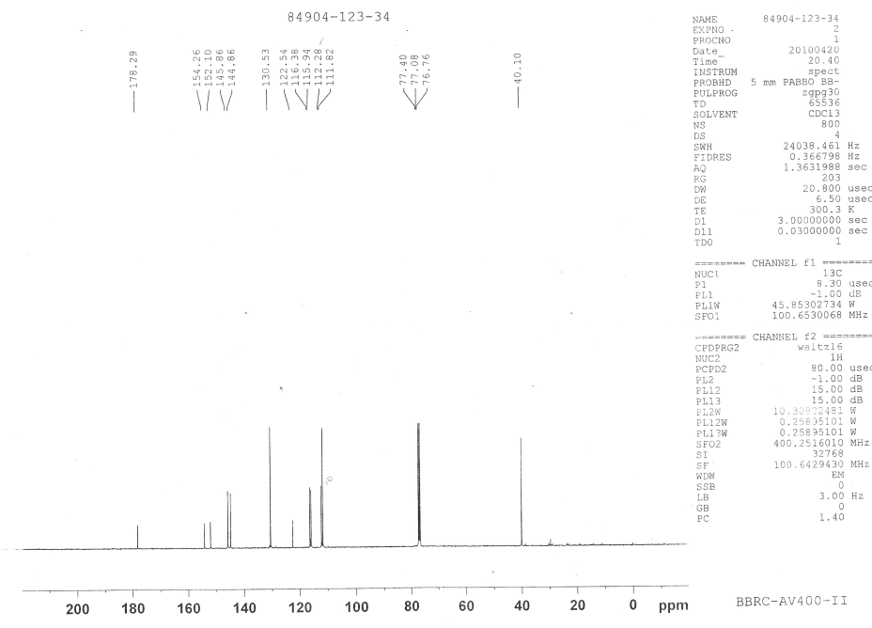

**Fig.2.47 13C NMR spectra of (E)-1-(furan-2-yl)-3-(4’ -N,N dimethylaminophenyl)prop-2-ene-1-one**

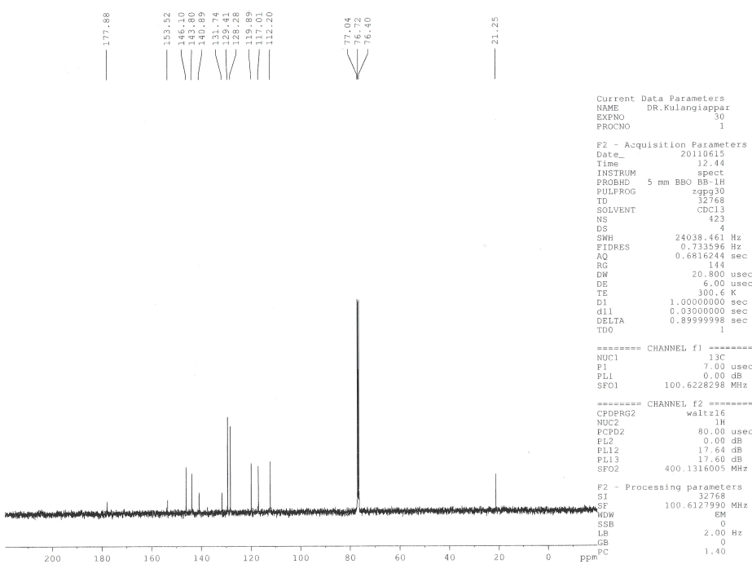

**Fig.2.48 13C NMR spectra of (E)-1-(furan-2-yl)-3-(4’ -methylphenyl)prop-2-ene-1-one**

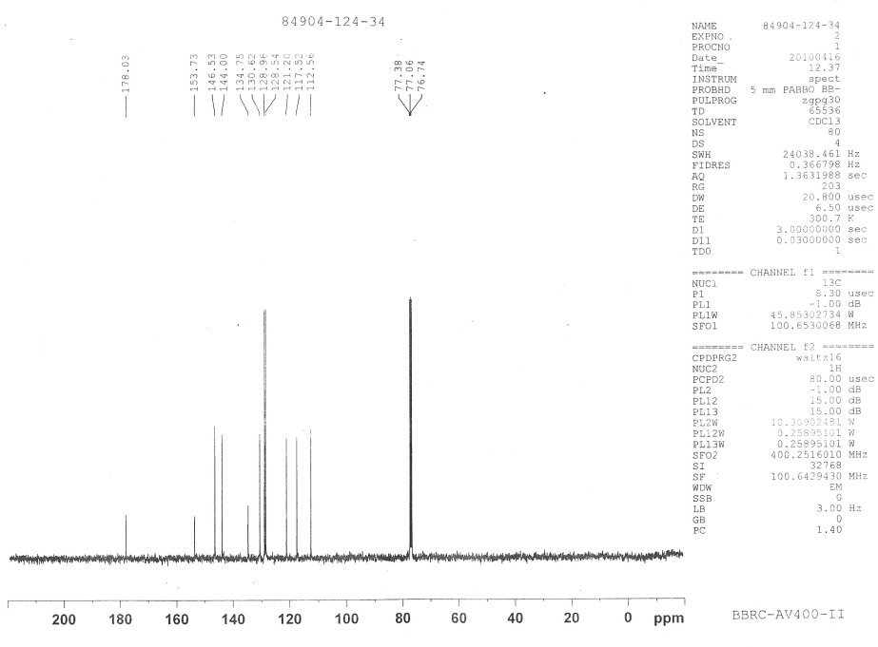

**Fig.2.49 13C NMR spectra of (E)-1-(furan-2-yl)-3-phenylprop-2-ene-1-one**

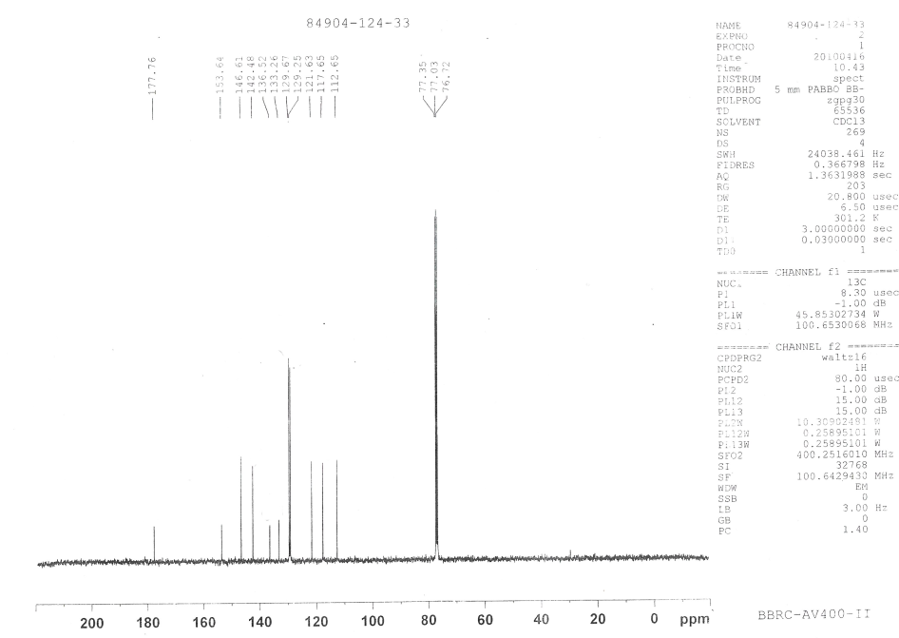

**Fig.2.50**  **13C NMR spectra of (E)-1-(furan-2-yl)-3-(4’-chlorophenyl)prop-2-ene-1-one**

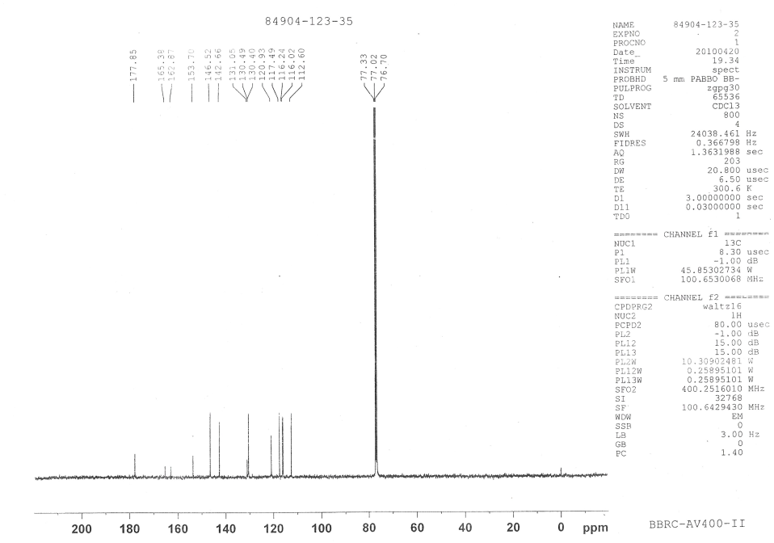

**Fig.2.51**  **13C NMR spectra of**  **(E)-1-(furan-2-yl)-3-(4’ -fluorophenyl)prop-2-ene-1-one**

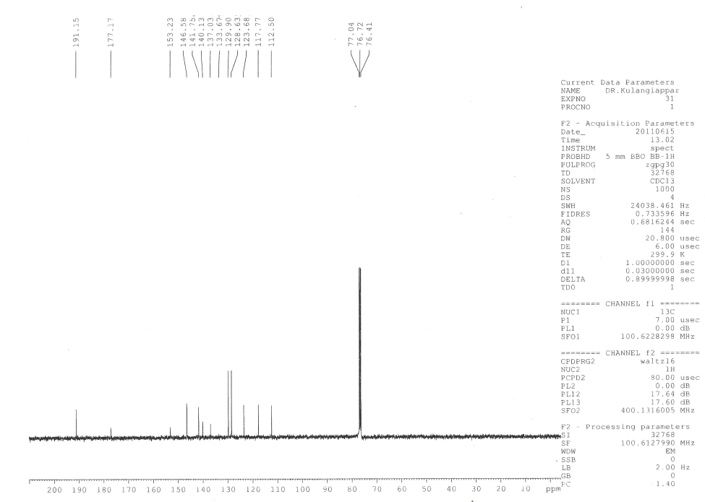

**Fig.2.52 13C NMR spectra of (E)-1-(furan-2-yl)-3-(4’ -oxophenyl)prop-2-ene-1-one**

* 1. **Antibacterial activity measurements**

Agar well-diffusion method was followed to determine the antimicrobial activity 4. Nutrient agar (NA) and Potato Dextrose Agar (PDA) plates were swabbed (sterile cotton swabs) with 8 hours old -broth culture of respective bacteria. Wells (6 mm) were made in each of these plates using sterile cork borer. Briefly, agar plates were inoculated with bacterial strain under aseptic conditions and wells (diameter = 6 mm) were filled with 50 µl of the test samples and incubated at 37°C for 24 hours. After the incubation period, the radii/diameter of the growth of inhibition zones were measured. The distance between center of the well to the edge of the zone was determined to be the inhibition zone radius. Three inhibition zone radii/diameter measurements were taken for each well and averaged, for each replicate the readings were taken in three different fixed directions and the average values were recorded. The average inhibition zone radii/diameter for the various bacteria are measured.

* 1. **References**

1. A.M. Islam and A.A. Khalaf, Indian *J. Chem*., **7**, 546-549 (1969).
2. S.Branko and A.Jursic, *J.Heterocyclic Chemistry*, **38**, 655-657,(2001).
3. Adam’s, Johnson. Wilcos, *Lab exp Org Chem*, 361-364,(1970).
4. V.Chandra Sekar, S.J. Knabel and R.J. Anatheswaran,*Food Sci Nutri*.,**3**,394-403,(2015).